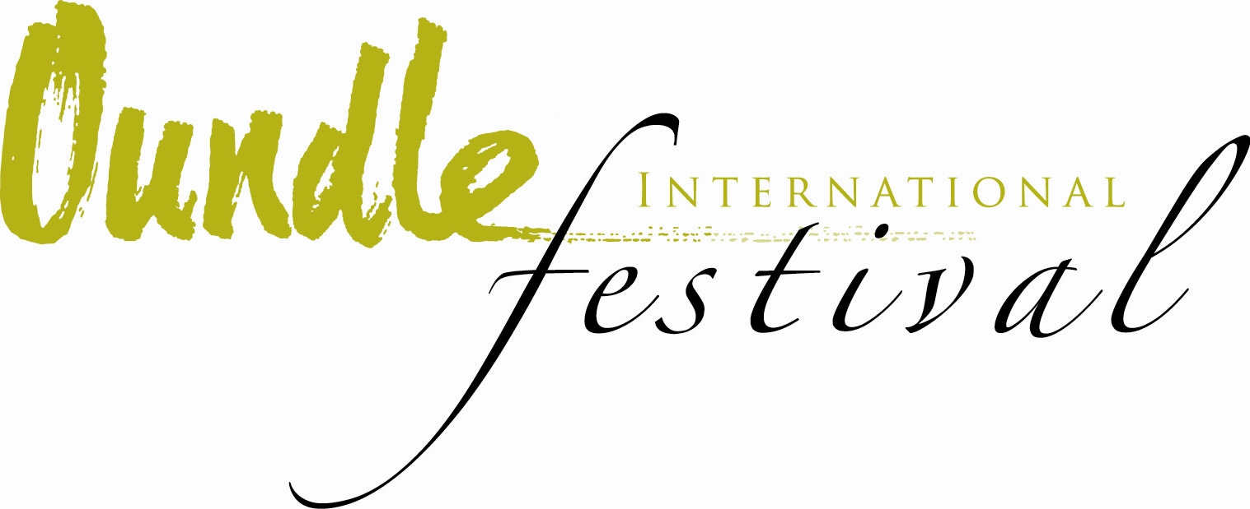
THE OUNDLE INTERNATIONAL FESTIVAL
8-16TH JULY 2016

THE VOICE is the theme of this year’s Festival, but according to Kenneth Richardson, the Artistic Director, it wasn’t necessarily a conscious decision. He explains, “I didn't so much choose the theme as it chose the Festival! As I was pulling together events it became clear that vocal music ranging from Renaissance Italy to energetic folk, smooth jazz and breath-taking opera was dominating the programme.” Back by popular demand is the golden opportunity for local singers to participate in a workshop led by one of the best early music vocal ensembles in the world, The Marian Consort, with the chance to be part of the choir in one of the performances (Breaking the Rules workshop on Saturday 9th July, Performance Friday 15th July).
The Oundle International Festival presents an impressive 20 events over the course of eight days. There is music for all music tastes: classical, reggae/ska, jazz, folk, Celtic/World and choral. There are big names such as multi-award winning choral performers, The Gabrieli Consort, and this is the only chance to hear their a cappella programme outside London, 80’s legends The Beat, the exhilarating internationally-acclaimed Jamie Smith’s MABON and the exquisite The Marian Consort who were part of the Radio 3’s line-up for the Free Thinking: Festival of Ideas as well as astounding young professional musicians who are just starting to forge their solo careers for whom this platform is an invaluable experience.
The Lunchtime Recitals have been programmed deliberately to fit inside a lunch break! Please come and relax at the performances which include: last year’s Oundle Young Musician of The Year, Reuben Goldmark on piano (Mon 11th July), a particular highlight this year is the winner of this year’s Junior Menuhin Competition, only recently announced as 12 year old Yesong Sophie Lee (Tues 12th July), if you love the violin or indeed have a child who is learning to play, what more inspiration could you ask for than coming to listen for 45 minutes to this young girl? Opera sung by award-winning mezzo soprano Olivia Warburton and piano performed by internationally acclaimed Irish pianist Maire Carroll are on the menu on Wed 13th July, celebrated US organist and Oundle for Organists tutor, Janette Fishell’s organ recital is on Thurs 14th July and, sponsored by the popular regional magazine Nene Valley Living on Fri 15th July, local girl and a previous Festival performer, saxophonist, Amy Green plays both classic and modern pieces and Christine Zerafa plays piano. All lunchtime recitals except Janette’s organ recital are in St Peter’s Church, Oundle 1pm-1.45pm.
There are three new events for 2016: At The Wharf, Luna Flix outdoor cinema presents an outdoor screening of GREASE (Sat 16th July) which is sponsored by The Beauty Room of Oundle- if you have any fancy dress gear that needs an outing or you’d like a Pink Ladies’ hair-do, the stylists will be on hand to help! There is an encore screening of a West End play (Oscar Wilde’s The Importance of Being Earnest with David Suchet as Lady Bracknell Sun10th July) which received 5* reviews when it was released and is hilarious! Definitely one for all the family. There’s an opportunity to dress up again for a country house soirée in the historic Great Hall at Deene Park for the poignant and amusing look at the life of Madame Clara Novello Davies in Novello & Son.

So, why is the Festival important to Oundle? Kenneth replies, “The festival is an important expression of creativity within the region and of local identity: it demonstrates to the outside world that Oundle is a place where interesting things happen. It is also important to the local economy bringing people into the town, particularly for the bigger events - Party at the Wharf (Sat 9th July) and the Food Festival (Sat 16th July).”
So, what would be the highlight this year? “I look forward to it all! My favourite thing is to see the transformation that happens to an audience over the course of a performance. People often arrive full of their worldly cares and by the end of the evening or lunchtime performance have entered a different state of being through the transformative power of music and drama.”
Between 8th-16th July there will be up to two concerts each day plus many informal events such as the immensely popular Illyria open-air theatre sponsored by the Ofsted rated ‘outstanding’ local nursery Small Wonders, outdoor cinema GREASE, Party at The Wharf-come with friends and family, rugs and picnics ready to party the night away to The Beat and The Tin Pigeons, The Bach Walk, featuring classical guitar soloist Simon Davies, which invites the audience to walk between two idyllic Northants villages enjoying a concert in two separate churches before concluding with informal supper, and of course to finish the week, there’s the highly-acclaimed popular gastronomic highlight of the week, the all-day Oundle Food Festival in the town’s Market Place.
The Artistic Director of The Oundle International Festival would like nothing more than to meet as many people as possible from the area and those visiting Oundle. He says, “In addition to our regular and loyal audience, I always hope to see new faces who are discovering the festival and its events for the first time, and hope that we convert them to regulars.”
To book tickets and for more information on The Oundle International Festival visit: www.oundlefestival.org.uk facebook.com/oundleinternationalfestival twitter @oundlemusic
Tel: 01832 274734 or in person at 4, New Street, Oundle, PE8 4ED

