FREE ORGAN

RECITAL
by

Sebastian Thomson
FRCO
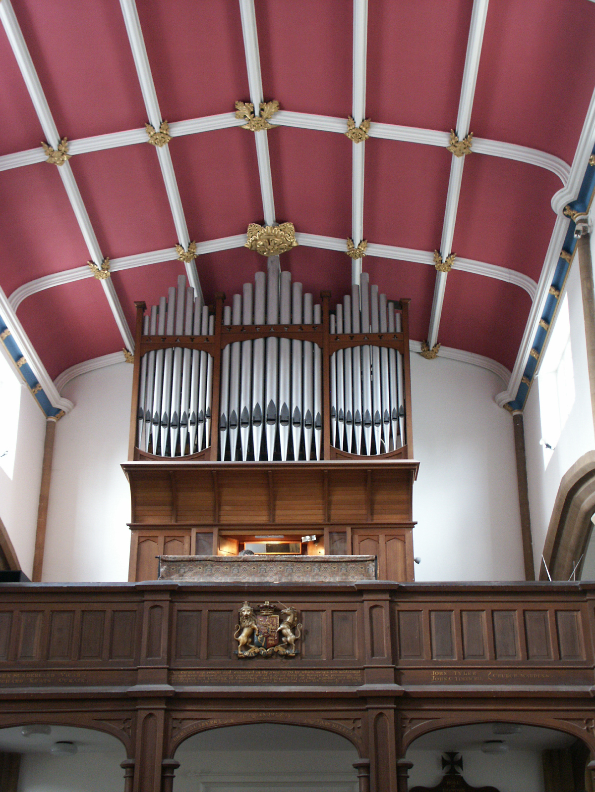
SATURDAY JUNE 18TH
St. ANDREW’S CHURCH WIVELISCOMBE 7.30 pm
Including music by Bach, Reger and Howells
and some Jazz
No booking required

Interval refreshments available

